Project Name **: CruisersElite**

|  |  |
| --- | --- |
| ­­­­­  Details of Project: |  |
| Client Name | St.Ann’s College of Engineering & Technology |
| Client Country | India |
| Number of Developers | 1 |
| Team Lead | Yaswanth Ravula |
| Website Link | cruiserselite.in |
| Responsive | Yes |
| Languages Used | HTML, CSS , JAVASCRIPT |
| Client Satisfaction | 4/5 |
| Delivery in | 6 days |

* Have a pilot look on each Module -

**1.Good Looking Navigation Header :**

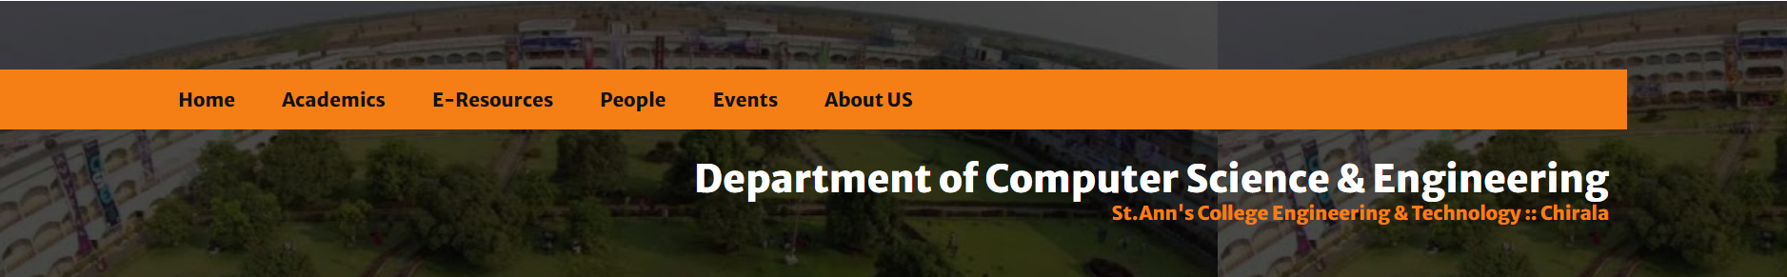

**2.Home Page :**

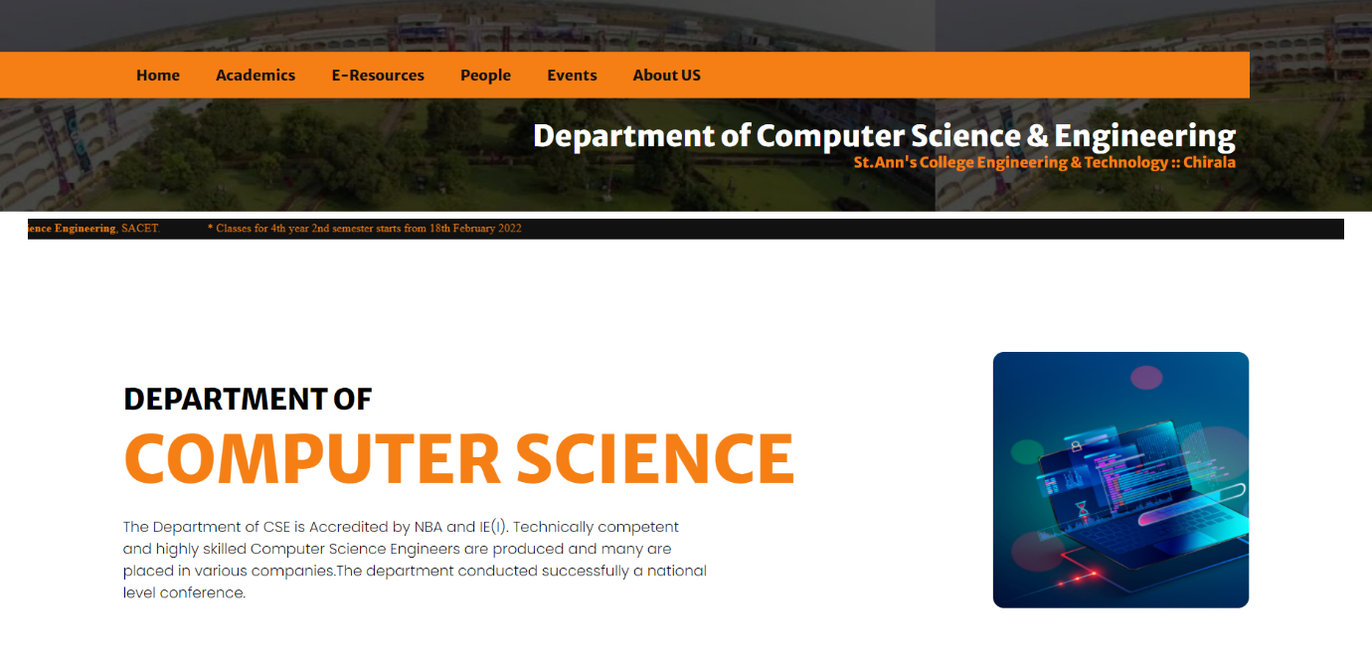

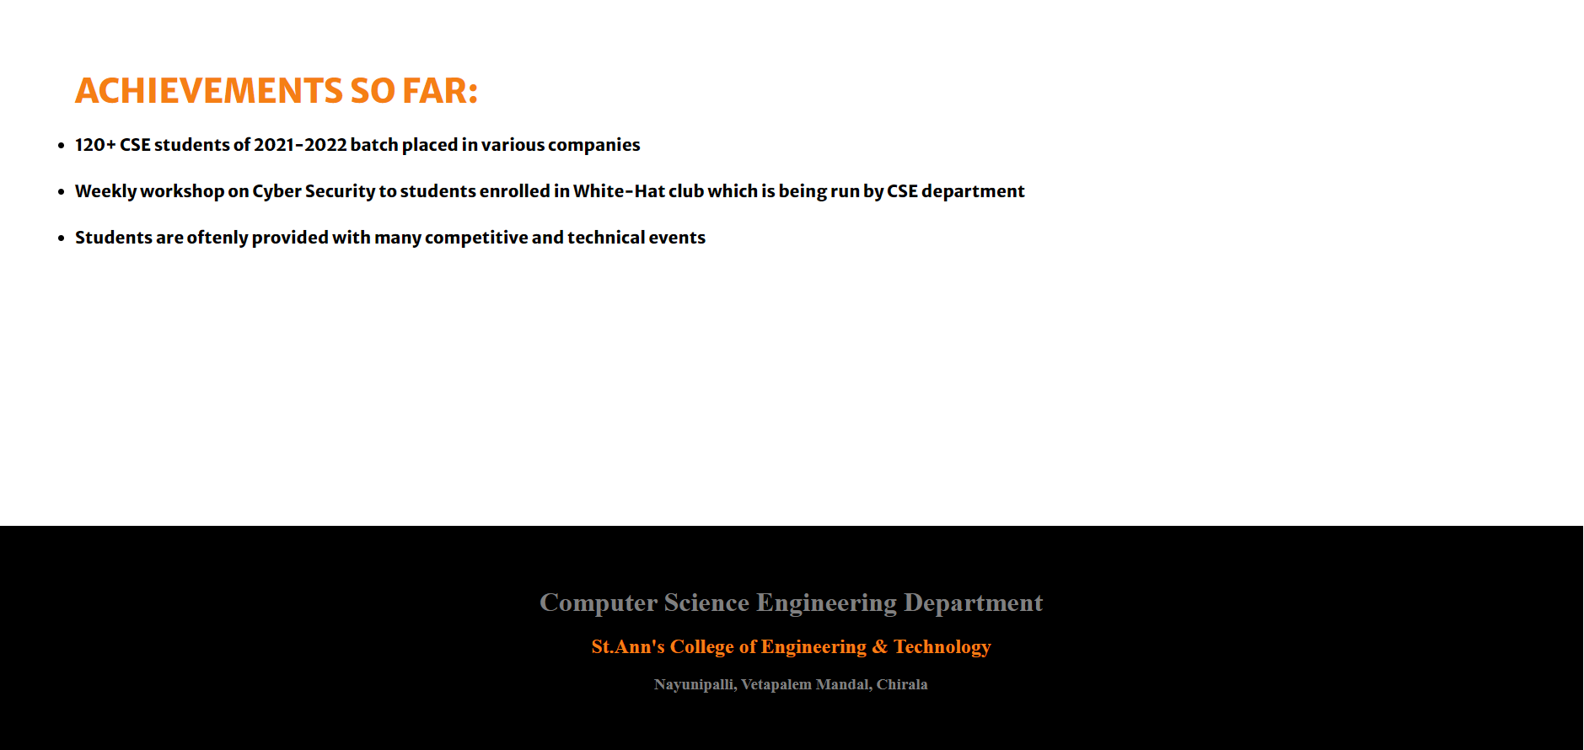

**­­­3. E-Resources Page :**

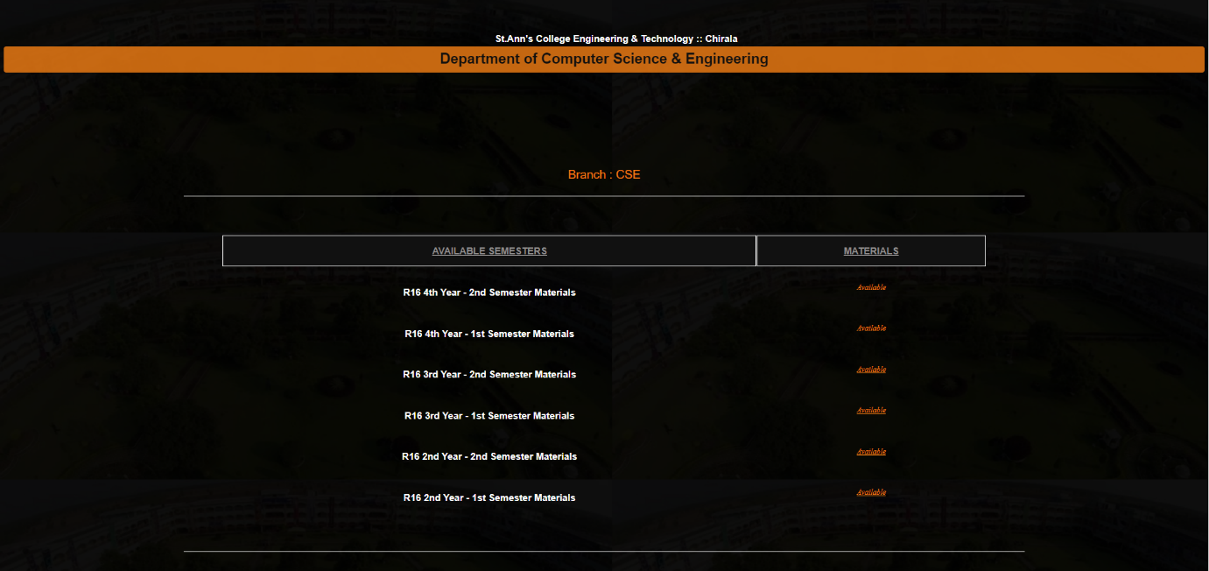

**4. People Page :**

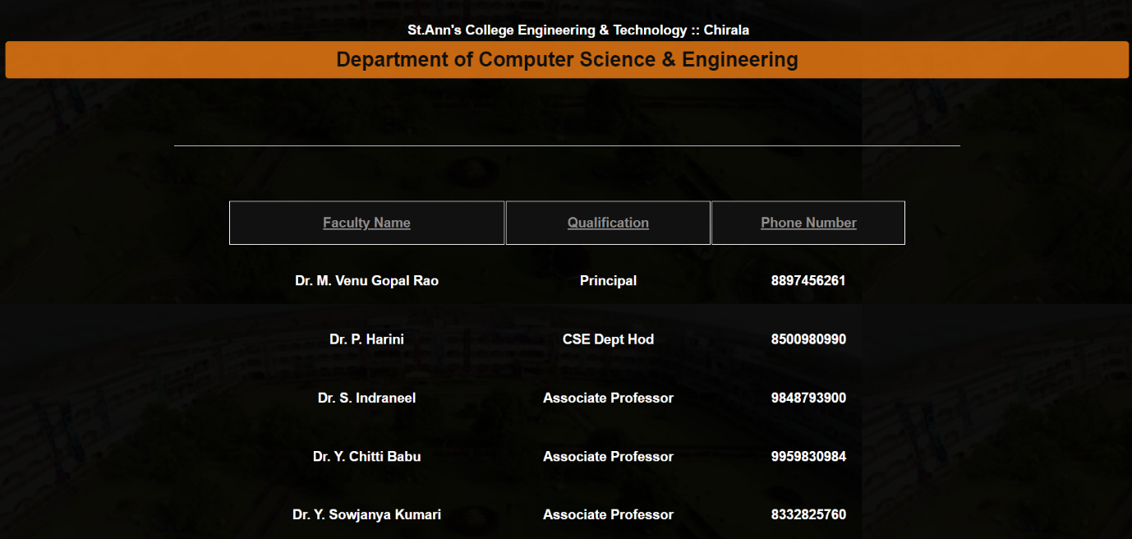

**5. Events Page:**

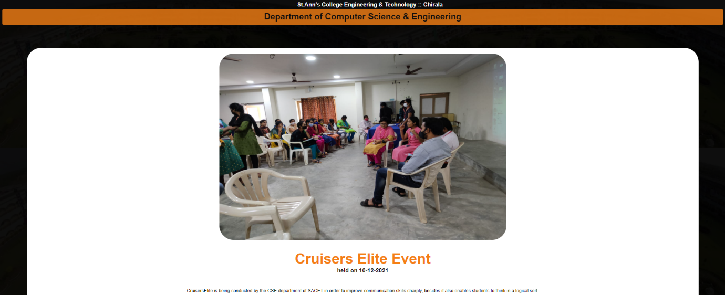

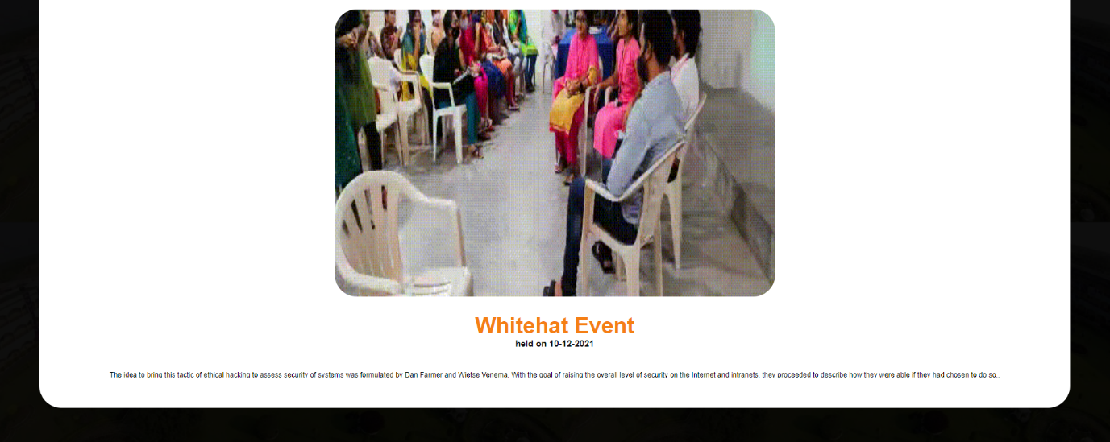

**6. Bottom Footer:**

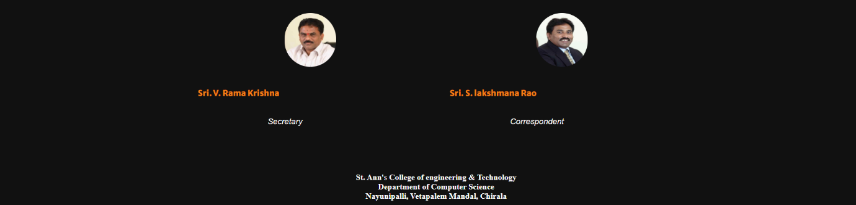

**7. About Us Page:**

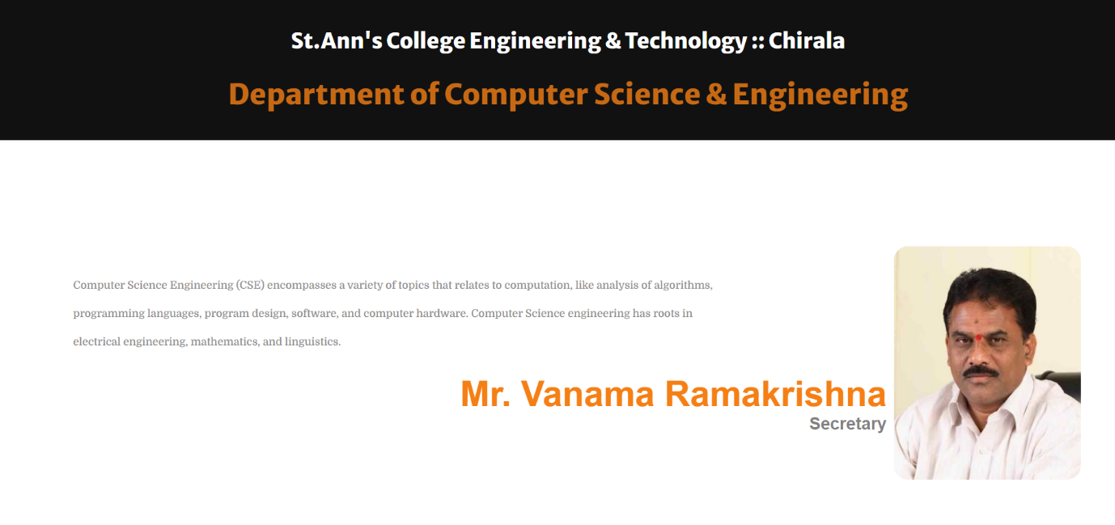

**8. Academics Page:**

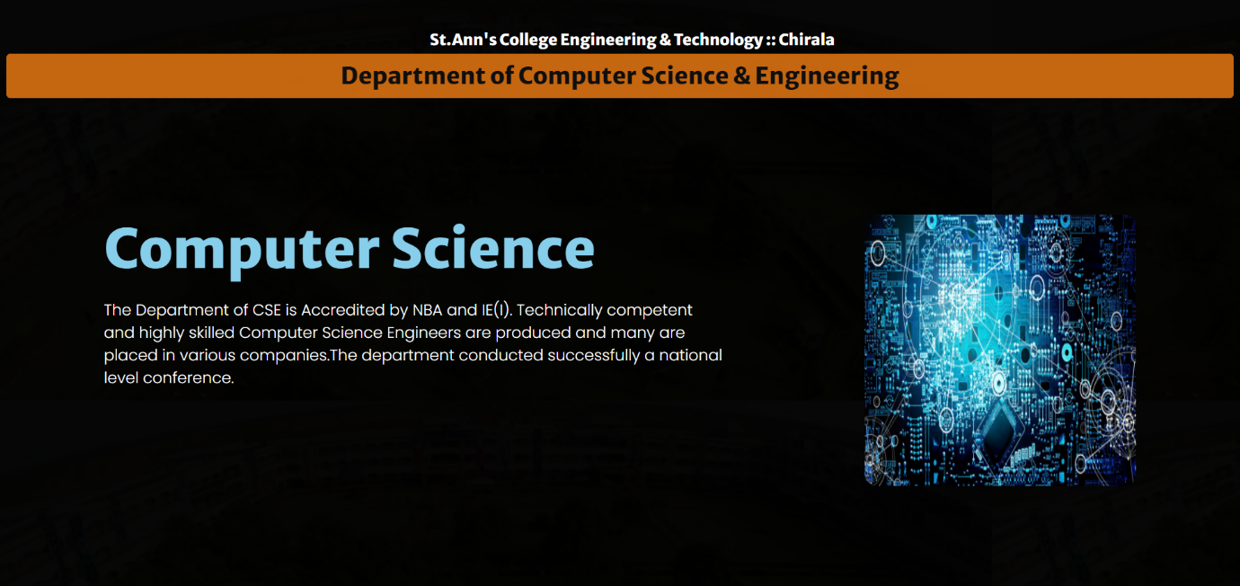

That’s It !

Thank You.

Stay Safe. Stay Healthy.